============================================================

SET 3

Q1. (Data Structures – 5 Marks)
Use AI to create a Python program implementing a Queue using the collections.deque module.
Perform:
- Enqueue 4 values
- Dequeue 1 value
- Display queue
Explain AI’s suggestion accuracy
Program
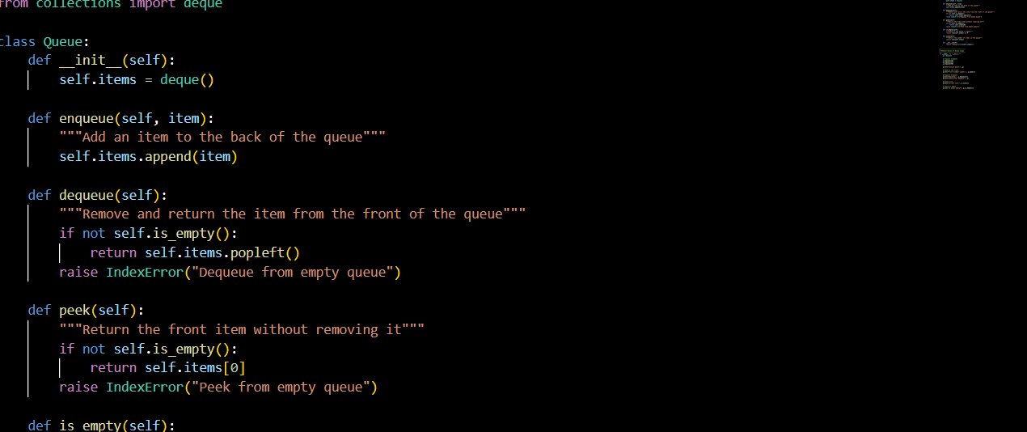
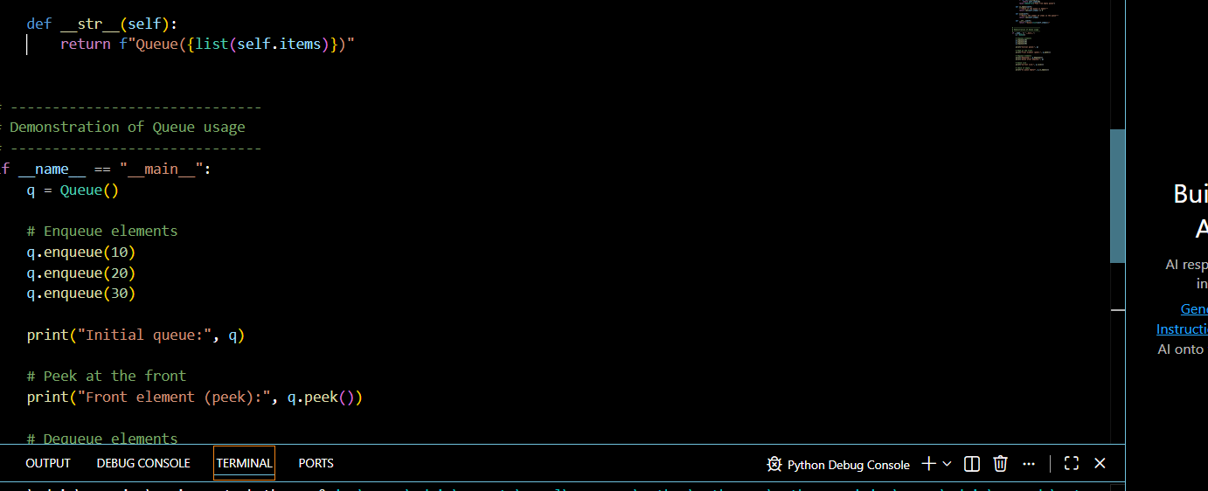

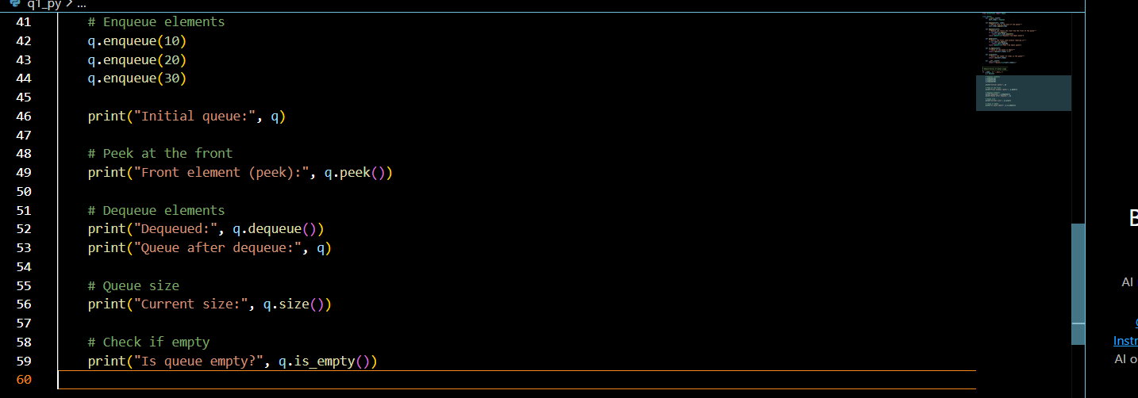
Output images
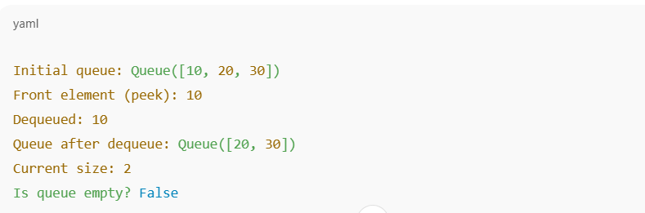

Q2. (Algorithms – 5 Marks)
With AI assistance, implement Binary Search in Python.
Test it on the sorted array:
[10, 20, 30, 40, 50, 60] to search for the number 40
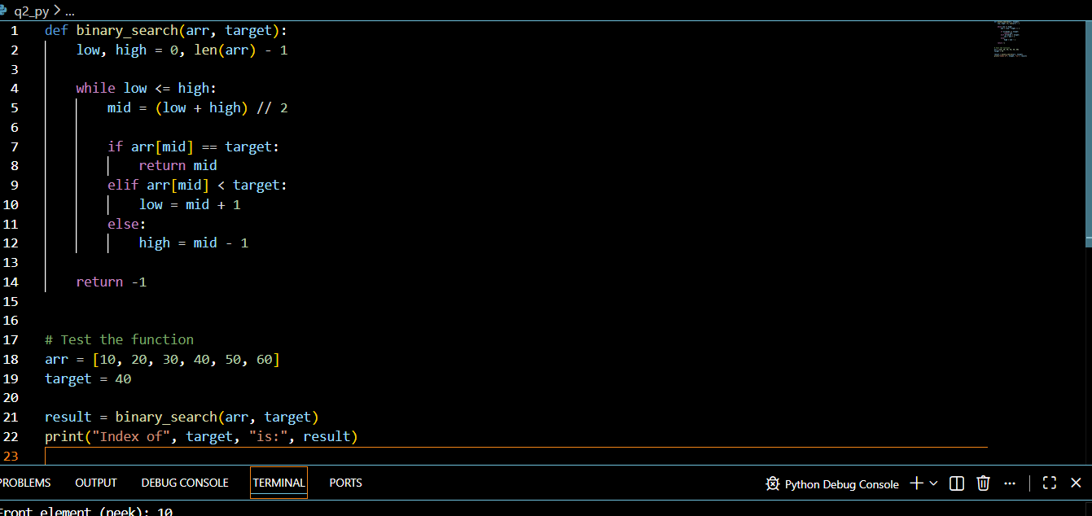.
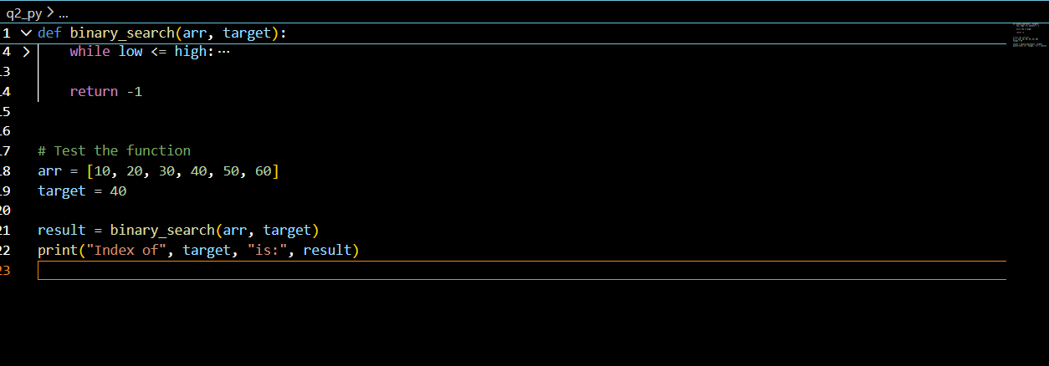
Out put image




